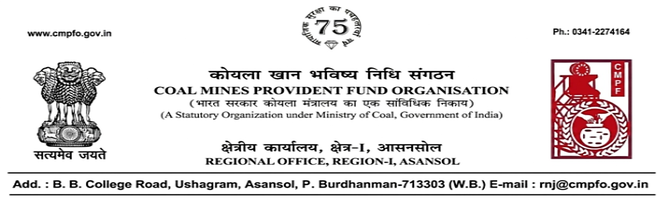
CPF/118/Misc./L.C.-out/R-I/ASN/ Date-21/07/2026

To
The Regional Commissioner
C.M.P.F ,Singrauli
PO-Jayant Dist-Singrauli-486890
Madhya Pradesh

Sub:- Inter Regional Transfer of Ledger Card, DA, PS -3 & 4.

Ref:- CPF/118/L.C.-REQ./SING/998 dated 09/07/2026

Sir,
In view of the revised Procedures prescribed in Procedure Office Order No-35 Dated-12.02.1975 of CMPF Commissioner,Dhanbad, I am to state that the Ledger Cards of the following members is hereby forwarded to your Regional Office. Further, it is informed that the Form A & P.S.-3 & P.S.-4 forms are not available in this region.
It has been ensured that the posting in the Ledger Cards have been made/updated for the periods the member was working in this Region.

SL. No | Name of the Member | CMPF A/C No | Name of the colliery where the member had earlier worked in | Name of the colliery where the member is currently working in
1 | Shri Mithilesh Kumar | RNJ/23/1043 | Shankarpur Colliery(RNJ/23)  Periods: 08.2006 to 04.2022 | Jhingurda Project  (SING/4)

Please acknowledge the receipt of the above at the earliest.
Yours faithfully,

(Ajay Kumar Singh)
Encl- Original L.C. (One Nos) Regional Commissioner - I

